Mandatory weekly group practice: Wednesdays 7:45 AM
Once every week/every other week with Mrs. Zacharias (15-30 minutes)
Sign up for practice times online
Feedback available online
Humorous
Serious
Oratory
Poetry
Storytelling (Heroes)
Duet
Reader’s Theater

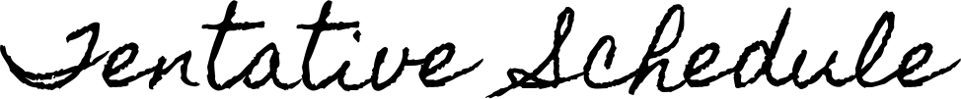
 | Arlington
 | Arlington
Oct. 5 | Florence OI Invitational #1
Oct. 18 | Orange & Black – Washington HS (Sioux Falls)
Oct. 19 | Florence OI Invitational #2
Oct. 21 | Harrisburg OI Tournament
Oct. 22 | Lennox HS Oral Interp Invitational
Oct. 26 | Karl E. Mundt Dakota Invite – Dakota State University (Madison)
Oct. 28 | Fall Festival Oral Interp Invitational – Brookings HS
Nov. 2 | Pumpkinstakes – Watertown HS
Nov. 3 | Colman-Egan Local Showcase (tentative)
Nov. 4 | Flandreau Invitational
Nov. 13 | DISTRICTS – United Methodist Church (Madison)
Nov. 19 | REGIONS – Augustana (Sioux Falls)
Dec. 6-7 | STATE – Yankton

*We will not be attending all of these meets. There are also meets that are not on this list that we may get invited to throughout the year. EVERYTHING is subject to change!

